Ideation Phase
Empathize & Discover

Date | 27 FEB 2026
Team ID | LTVIP2026TMIDS41352
Project Name | ShopEZ:One-Stop Shop for Online Purchases
Maximum Marks | 4 Marks

Empathy Map Canvas:
Empathy Map – ShopEZ
User Persona: Sarah – A Busy Working Professional
Goal: To quickly purchase a meaningful birthday gift for her friend.

Empathy Map Structure
THINKS
- Is this the right gift for my friend?
- Will the product match the description?
- Is this website secure for payment?
- Will the order arrive on time?
SAYS
- I don’t have much time to search.
- I need something stylish and affordable.
- I hope the checkout process is simple.
- I want reliable delivery.
DOES
- Uses filters to narrow down product options.
- Reads product reviews carefully.
- Compares prices and ratings.
- Adds the selected item to the cart and completes the purchase.
FEELS
- Stressed because of limited time.
- Confused when too many options are displayed.
- Concerned about payment security.
- Relieved after placing the order successfully.
- Happy when the gift arrives on time.

Insight from the Empathy Map
By understanding Sarah’s thoughts, actions, and emotions, we identified the need for:
- A simple and clean user interface
- Smart filtering and search functionality
- Secure authentication and checkout system
- Clear order confirmation and tracking
This empathy mapping exercise helped us design ShopEZ based on real user needs rather than assumptions.
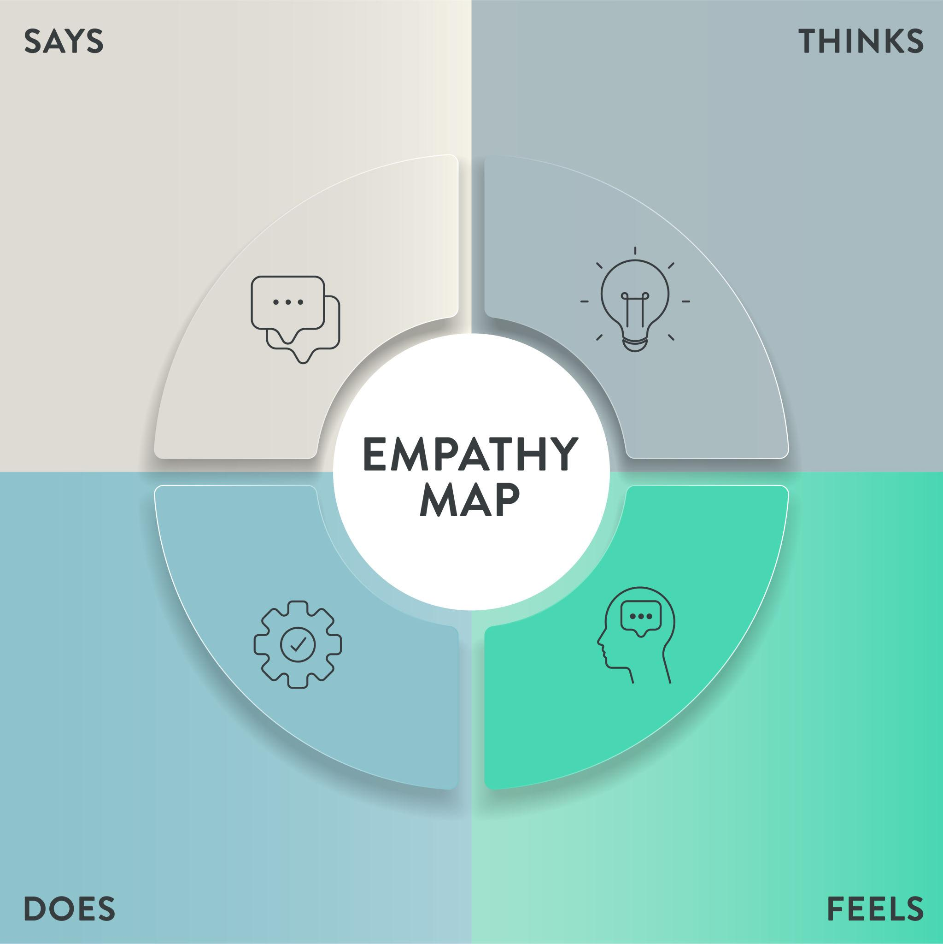

Reference: https://github.com/sridinesh04/MERNSTACK-_SHOPEZ-SHOP-TO-STOP-.git

Example: Food Ordering & Delivery Application
